Supplemental information for
More than one landslide per road kilometer – surveying and modeling mass movements along the Rishikesh-Joshimath (NH-7) highway, Uttarakhand, India
Jürgen Mey¹, Ravi Kumar Guntu^{2,3}, Alexander Plakias^{1,4}, Igo Silva de Almeida¹, Wolfgang Schwanghart¹

Remark
This document contains five additional figures and two tables. The data and figures detail the results of the landslide susceptibility models conducted with different rainfall/precipitation products.

Supplemental figures

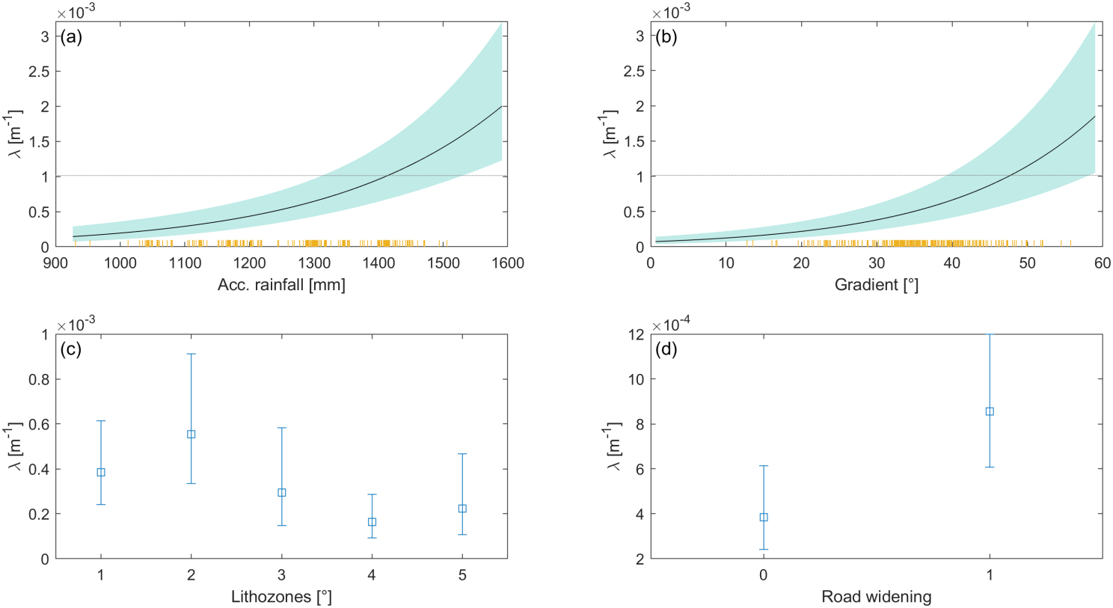
S1: Individual effects of model parameters on landslide density with CHIRPSv2 as rainfall product.
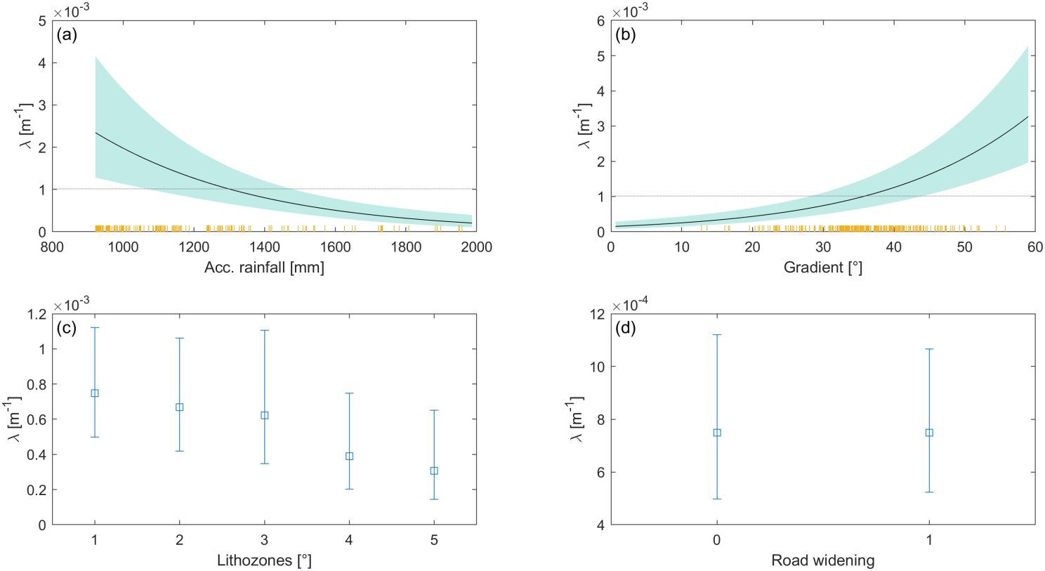
S2: Individual effects of model parameters on landslide density with IMD1 as rainfall product.

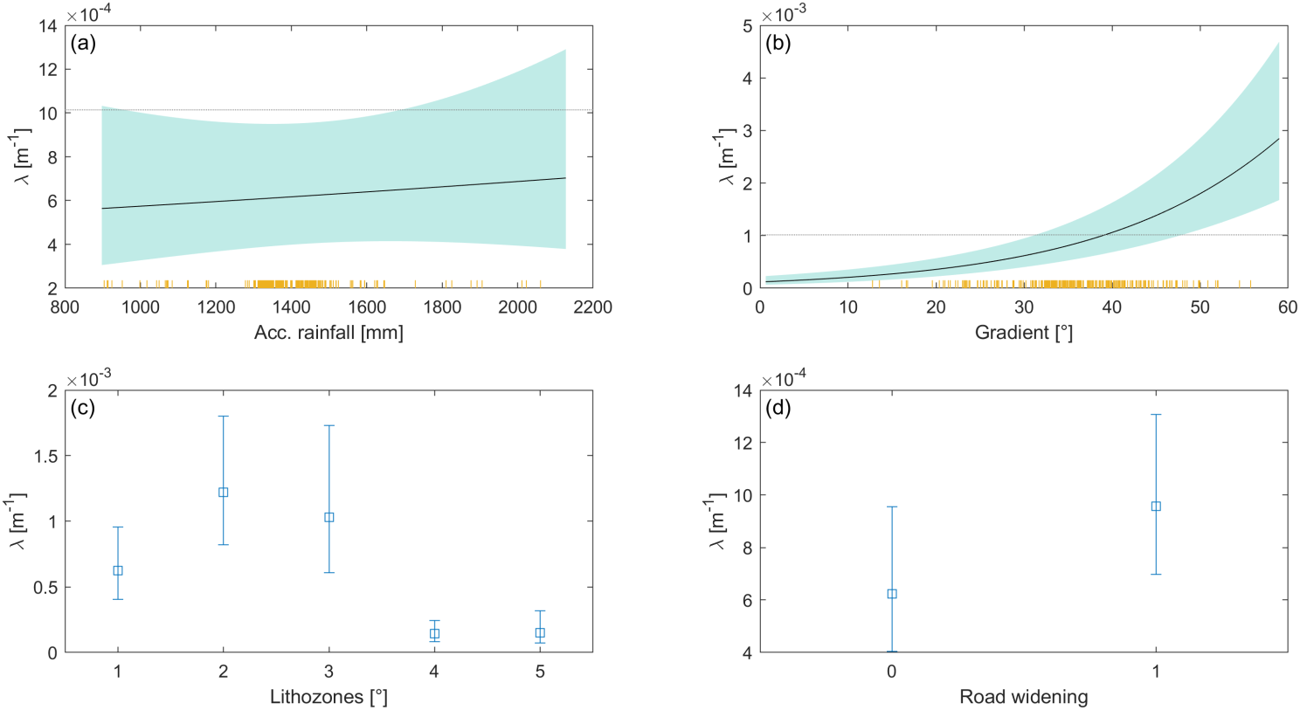
S3: Individual effects of model parameters on landslide density with IMD2 as rainfall product.

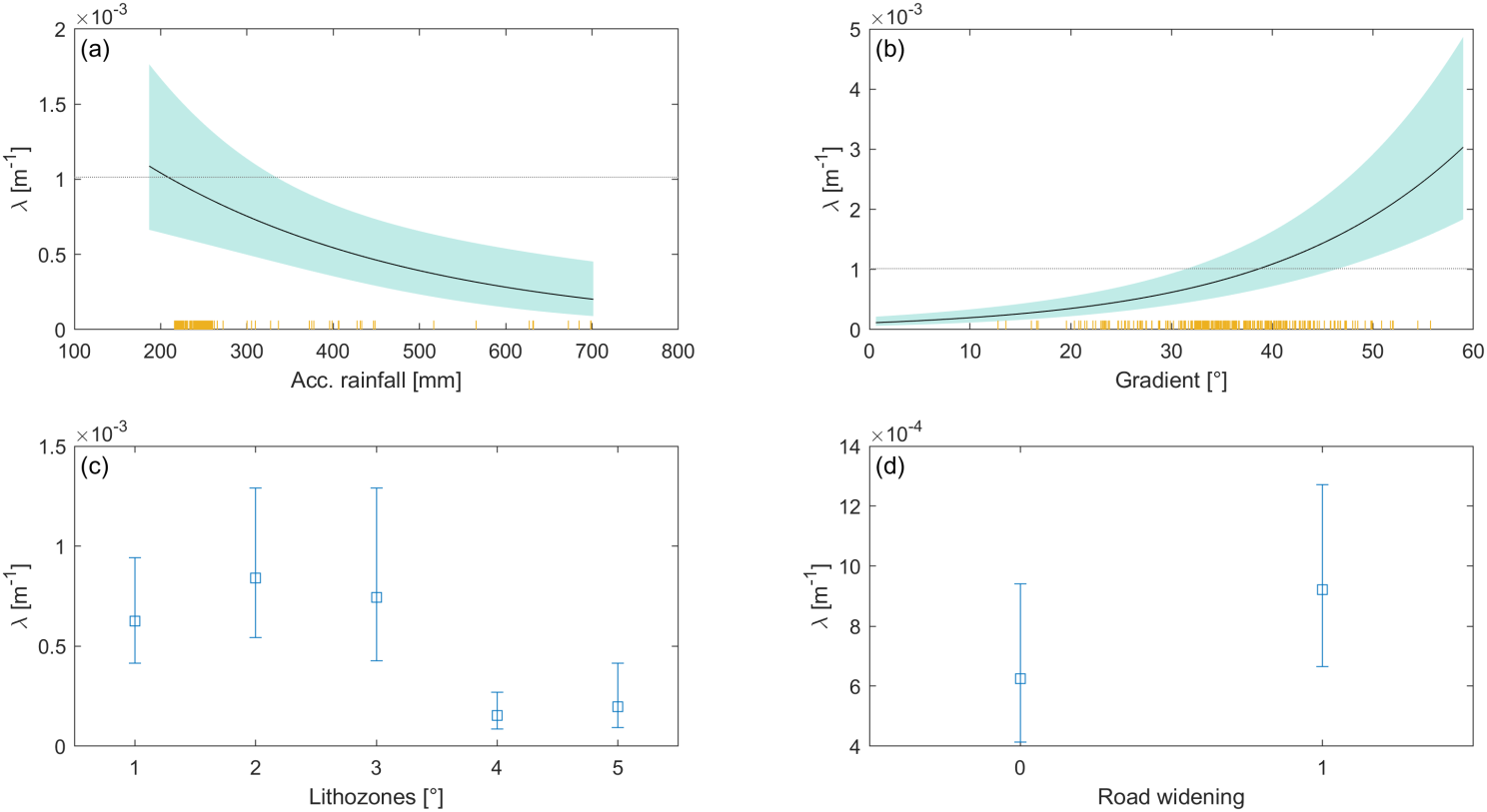
S4: Individual effects of model parameters on landslide density with IMERG as rainfall product.

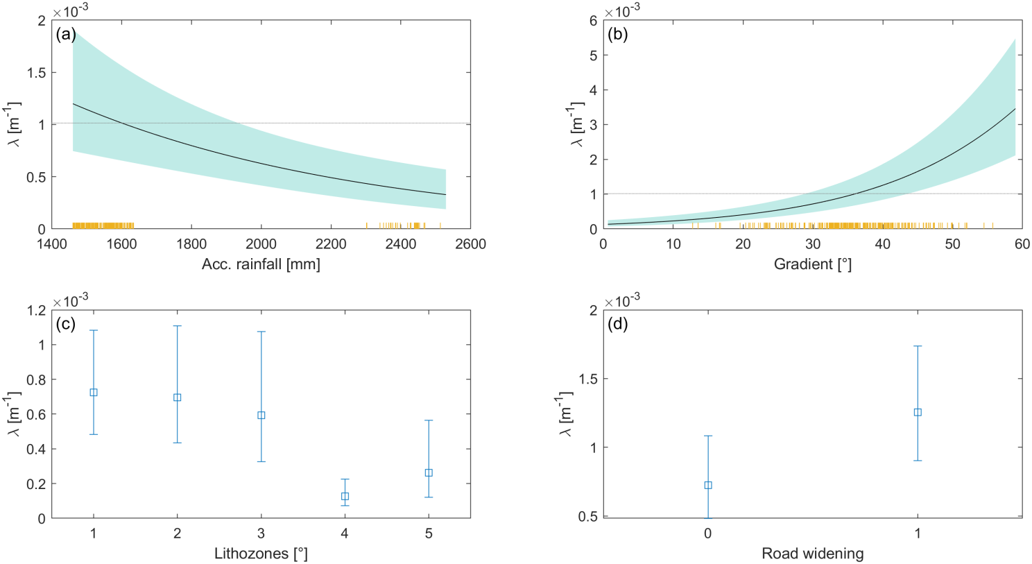
S5: Individual effects of model parameters on landslide density with MSWEP as rainfall product.

Supplemental tables
S6: Coefficients of models including different rainfall products.
 | CHIRPSv2 | IMD1 | IMD2 | IMERG | MSWEP
Rainfall | 0.00406 +/- 0.000679 | -0.00236 +/- 0.000482 | 0.000183 +/- 0.00037 | -0.00334 +/- 0.000985 | -0.00124 +/- 0.000307
Gradient | 0.0564 +/- 0.00733 | 0.0545 +/- 0.00751 | 0.0556 +/- 0.00725 | 0.058 +/- 0.00724 | 0.0579 +/- 0.00732
Lithology L2 | 0.371 +/- 0.184 | -0.116 +/- 0.227 | 0.695 +/- 0.192 | 0.302 +/- 0.201 | -0.0426 +/- 0.23
L3 | -0.272 +/- 0.285 | -0.19 +/- 0.293 | 0.518 +/- 0.272 | 0.179 +/- 0.277 | -0.204 +/- 0.303
L4 | -0.866 +/- 0.314 | -0.666 +/- 0.339 | -1.49 +/- 0.289 | -1.43 +/- 0.287 | -1.76 +/- 0.294
L5 | -0.549 +/- 0.423 | -0.909 +/- 0.4 | -1.43 +/- 0.395 | -1.17 +/- 0.388 | -1.03 +/- 0.405
RW | 0.815 +/- 0.22 | -0.000176 +/- 0.218 | 0.441 +/- 0.201 | 0.398 +/- 0.199 | 0.569 +/- 0.204
Intercept | -10.7 +/- 0.976 | -1.87 +/- 0.783 | -5.73 +/- 0.608 | -4.34 +/- 0.454 | -3.04 +/- 0.657
AIC | 1876 | 1887 | 1913 | 1900 | 1897
S7: Weekly rainfall departures (%) for Uttarakhand districts 01-10-2022 to 07-12-2022ª.
 | Week End
District | 5-10-2022 | 12-10-2022 | 19-10-2022 | 26-10-2022 | 02-11-2022 | 09-11-2022 | 16-11-2022
Almora | -78 | 2499 | -64 | 138 | -100 | -100 | -100
Bageshwar | -49 | 2619 | -59 | 282 | 820 | -67 | -100
Chamoli | -67 | 1855 | 20 | -63 | -48 | -100 | 67
Champawat | -96 | 1253 | -85 | 70 | -100 | -100 | -64
Dehradun | -15 | 317 | -56 | -85 | -100 | -100 | -30
Haridwar | -100 | 763 | -100 | -100 | -100 | -100 | -100
Nanital | -17 | 2308 | -100 | -95 | -100 | -100 | -100
Pauri Garhwal | -99 | 679 | -83 | -90 | -100 | -100 | -45
Pithoragarh | -40 | 912 | -78 | -59 | -50 | -100 | -77
Rudraprayag | -20 | 218 | 23 | -55 | -100 | -100 | 342
Tehri Garwal | -74 | 419 | -94 | -95 | -100 | -100 | 250
Udham Singh Nagar | -100 | 2218 | -100 | -100 | -100 | -100 | -100
Uttarkashi | -63 | 88 | 326 | -11 | -100 | -100 | 264
ª https://mausam.imd.gov.in/imd_latest/contents/rainfall_statistics_2.php

